OUTPUT Lab2:

Calculator_Server:

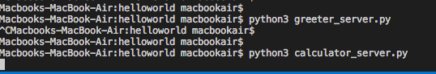

Calculator_Client:

